Monitoring Task
Task Description:

Install Prometheus and Grafana on a Linux EC2 machine, connect Prometheus to Grafana, and create a dashboard to view metrics

Prometheus installed :
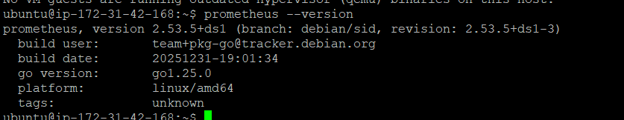

Grafana installed and logged in :

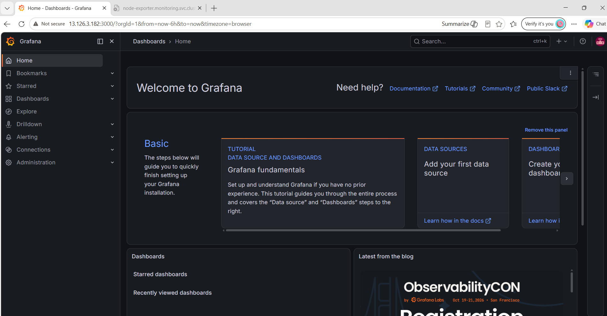

Grafana Dashboard created with EC2 ipaddress that we have installed Prometheus :

